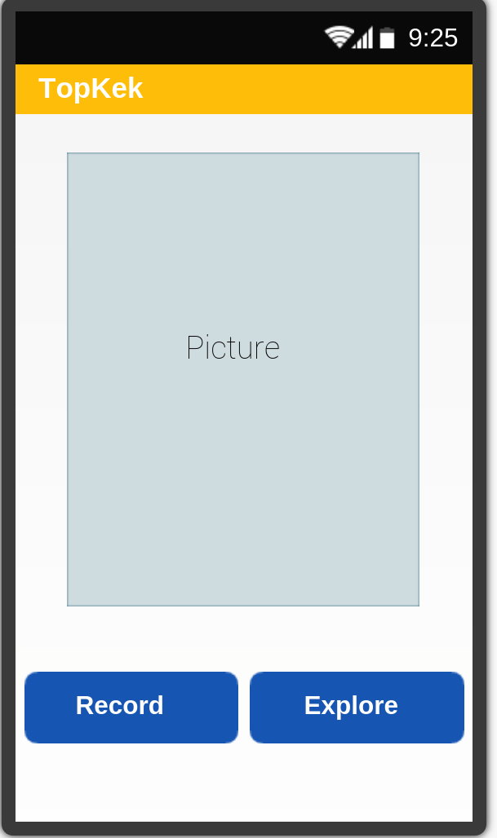

Home Page
This is the page that the user will see as soon as they open the application (RPSRrec) giving them two options. The “Record” button will take them to the “User Data Page”, whilst the “Explore” button will guide them to the “Explore Page”.

It is important that this page is aesthetically pleasing, and is easy to navigate to give a positive first impression of the application (RPSRrec). If it is decided in the future that the guest area is not needed then the “Explore” button can be deleted and the “Record” button would be centred.

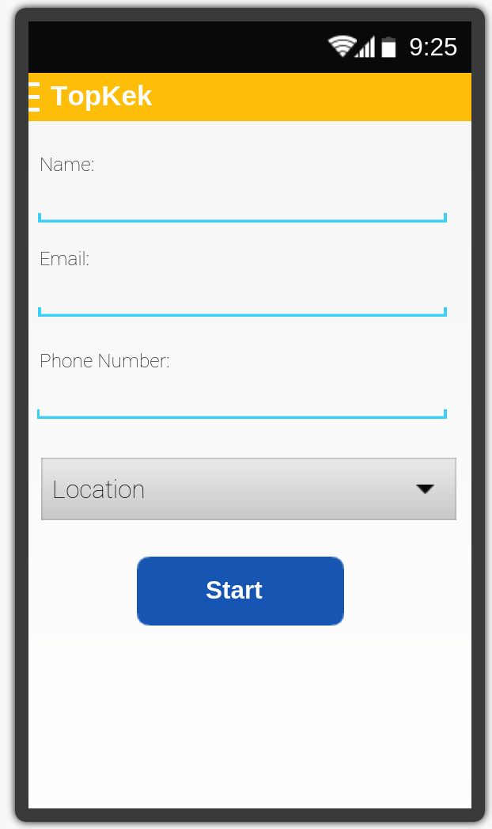
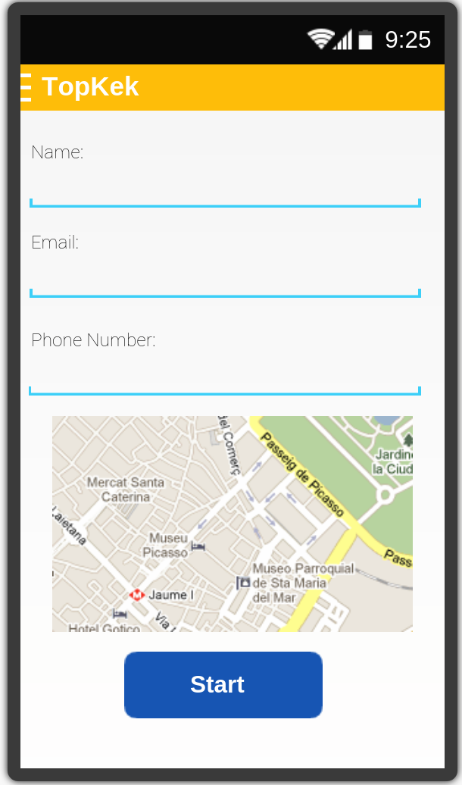

User Data Page(s)
These are two designs for the personal details page, they allow for the user to put in their details on the corresponding lines. If the user has their GPS enabled then the design on the left should be shown, with the map showing the user's position. If the GPS is disabled then the design on the right should be shown with a drop down list of all possible nature reserves. Pressing start will bring up the “Blank Record Page”.

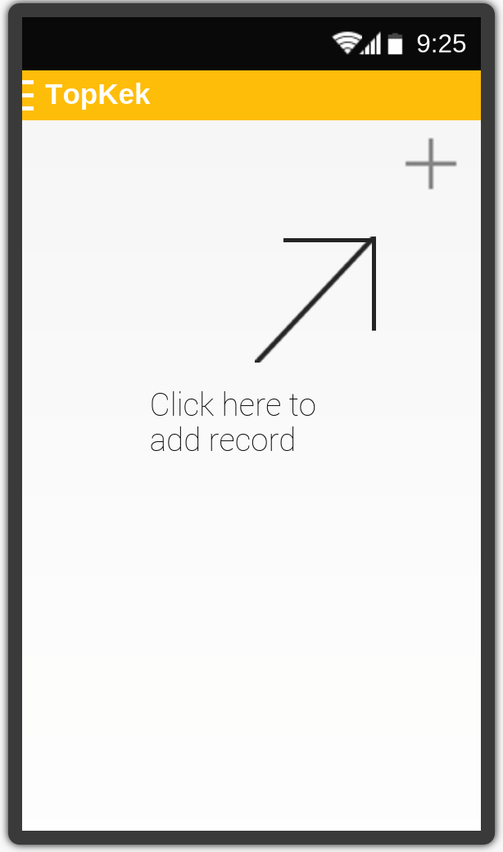

Blank Record Page
This page will display after the user has entered their details. It is a blank record page with a simple graphical element displaying how to add a record.
This page should only be seen whilst no records have been added. Clicking the “+” in the top right corner will take the user to the “Add Record Page”.

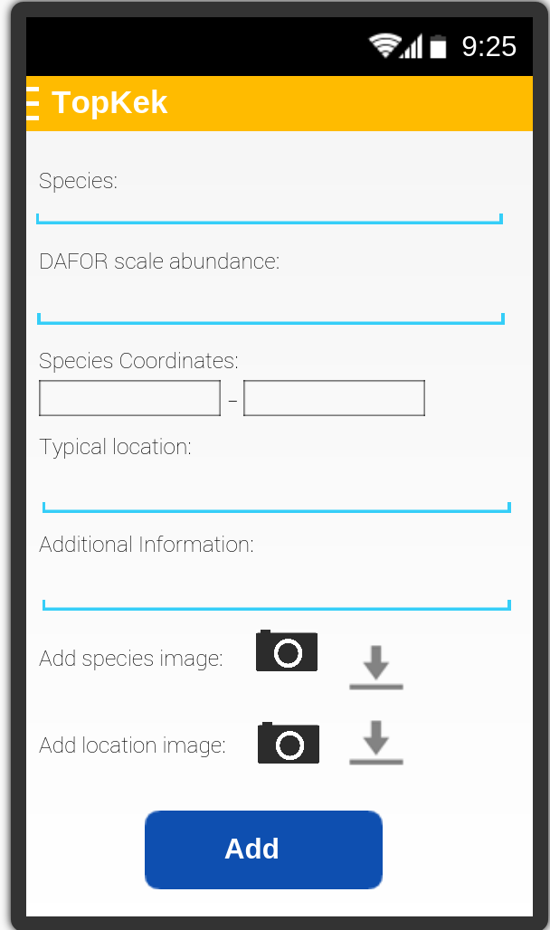
Add Record Page
This page will allow the user to add a record easily, the user must simply fill in the fields for the species that they are currently recording.

Towards the bottom of the form you can add a picture of the species and/or the surrounding location. Both the symbols that link you to do this are placeholder images (and will be changed during the implementation). The camera icon will allow the user to activate their camera and take a picture to add to the form, whilst the down arrow symbol will allow the user to add a picture from their current gallery to the form.

Upon completion of the form, clicking the “Add” button will take the user to the record page with the newly filled out record on display.

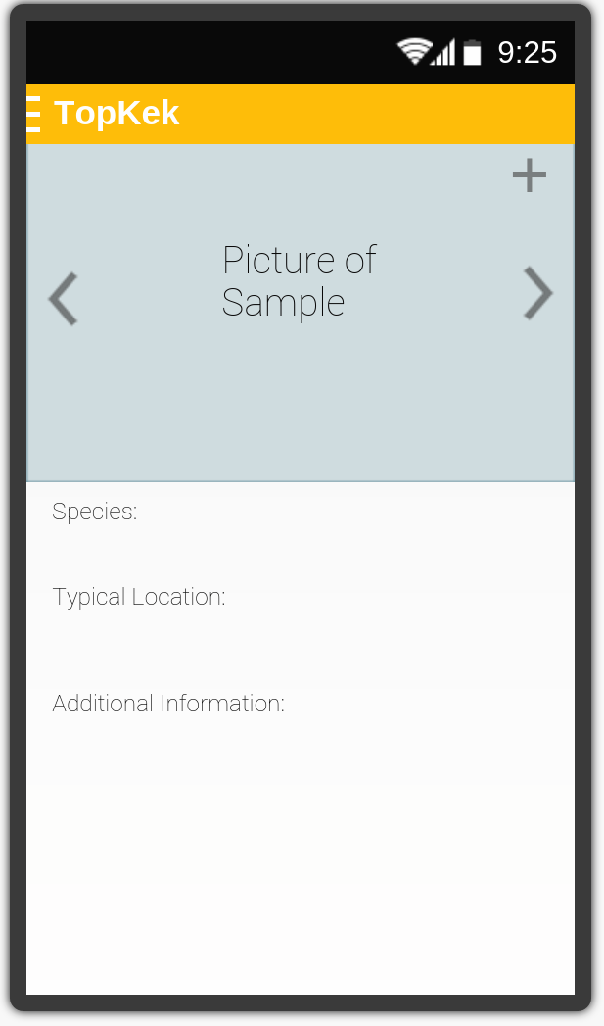
Record Queue Page
This is the page that allows the user to navigate between all of their previously added records by swiping to either side.

Clicking the “+” in the top corner will allow the user to add a new record.

Clicking on the “hamburger” in the top left corner next to the place holder logo you will be able to select “Edit” which will take you to the Add Record page where the fields will already be filled with the previous information.

By clicking on the arrows in the picture the user can cycle through all of their current images for that specific species record, and then by pressing the image they bring up a new page which gives them a closer look at the pictures.

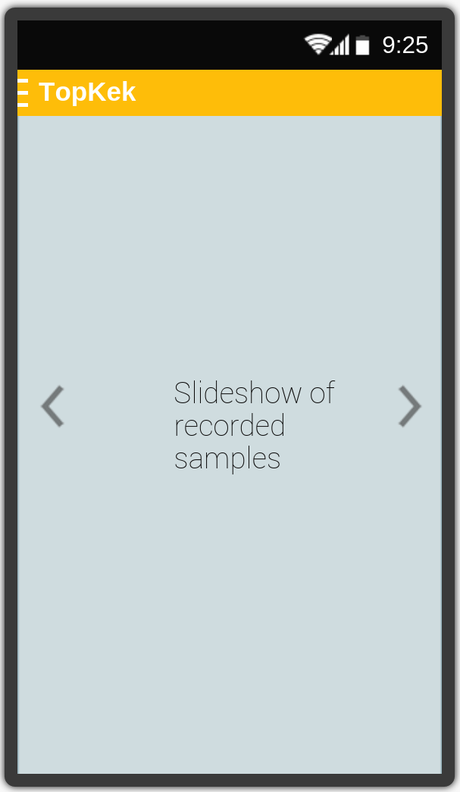
Image Viewing Page
In this page the user can swipe through all of their images for a specific species. This page has no functional use however, and so therefore is expendable.

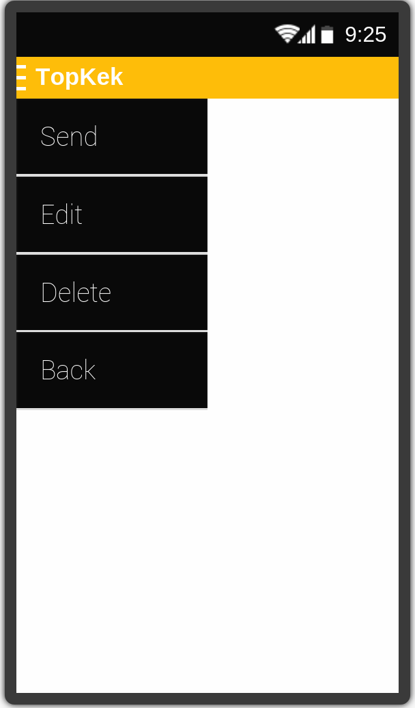
Side Menu
This image illustrates the menu which appears when the user clicks the “hamburger” in the top left corner. This menu should appear on all pages except the “Home Page”.

The “Send” option will send the record information to the server database. This option should only be visible from the “Record Page”.

The “Edit” option will allow the user to edit previously input records. This option should only be visible from the “Record Page”.

The “Delete” option will allow the user to delete records. This option should only be visible from the “Record Page”.

The “Back” option will take the user to the previous page. This option should be visible from all pages excluding the “Home Page”.
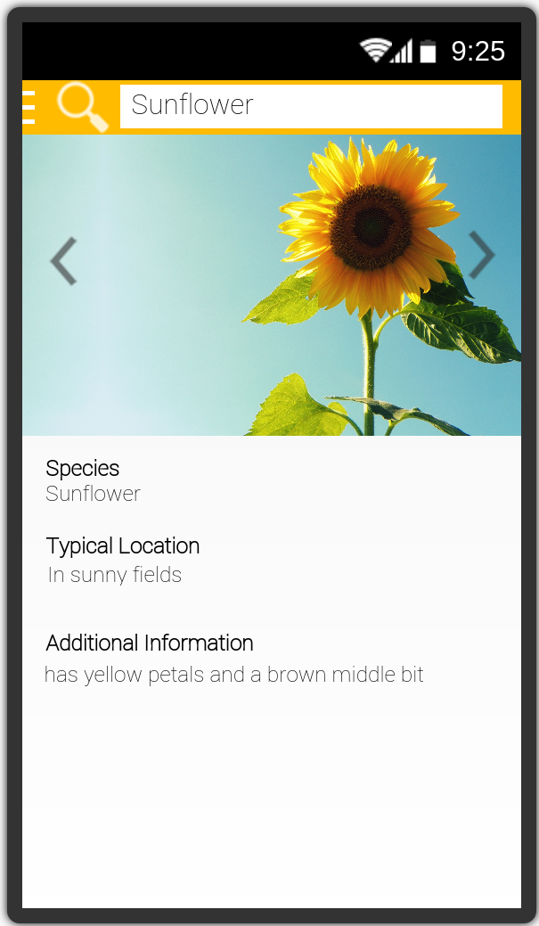

Explore Page
This page is navigated to using the “Explore” button on the “Home Page”. The page allows people to see a selection of previous community records without having to add any of their own. Records can not be added or removed from this page. There is also a search feature that you can use to browse content of a specific species or a specific users content.

